1. **Agenda**:
   1. **How to write reg expression to match URL.**
2. In our earlier lectures, we created stub matching URL Path 🡺 /student/1  
   But now we want to create a stub which matches /student/<any-number>
3. **Adding one more stub with regex URL Path**  
   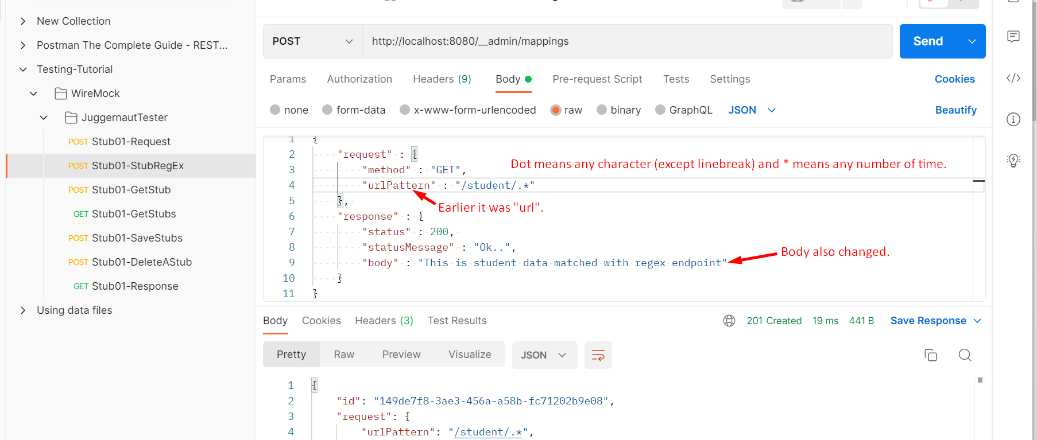
4. 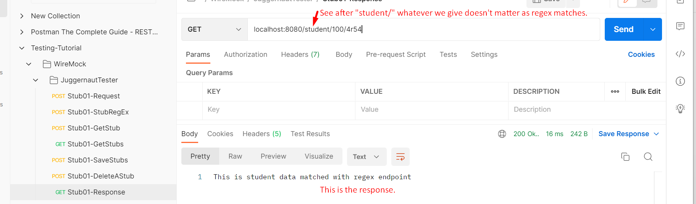
5. 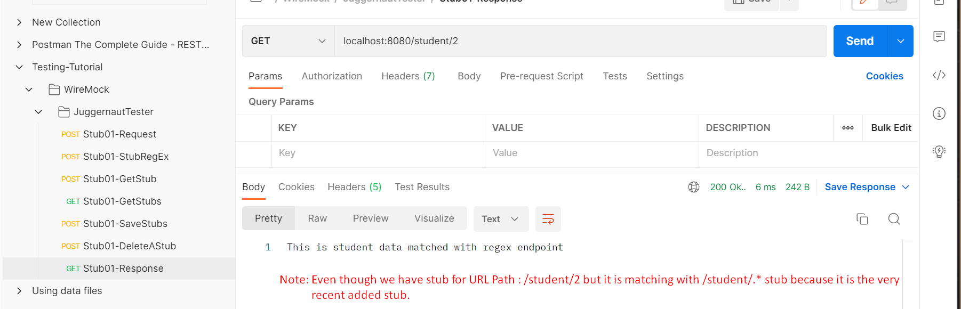
   1. Let’s talk about the case when more than one stub matches.  
      Before that keep in mind that default priority of a stub is 5 and lowest the number, highest the priority.  
      Second, it doesn’t matter if the matching stub is generic stub means regex (/student/.*) or a specific stub (/student/.*)
      1. **Case 01: If we don’t define any priority for those two matching stubs**
         * Then the last added stub will win.
      2. **Case 02: If we define priority**
         * Then the stub with lowest priority will win.